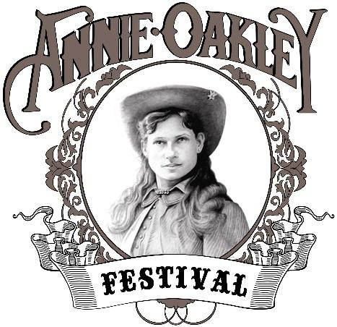
Annie Oakley Committee, Inc.
PO Box 129 Greenville, OH 45331
http://www.annieoakleyfestival.org
2021 Annie Oakley Festival
July 23, 24, & 25, 2021

The Annie Oakley Festival Committee members are very proud and excited about the upcoming 2021 Annie Oakley Festival. We were obviously very disappointed that we had to cancel the 2020 Annie Oakley Festival, which would have been our 57th year of being a festival that honors Darke County’s most famous daughter, Annie Oakley. We have already started making plans for the 2021 Annie Oakley Festival, and we are hoping are praying that this year, our festival will be bigger and better than past years. We are looking at what we, as a committee, need to do to make this year’s festival as safe as possible for all those who attend. We are looking at spacing, sanitizing, and planning events so that everyone can enjoy. Each year, our goal is to make our festival FREE to all who attend. Every activity that takes place at the Annie Oakley Festival is only made possible through the sponsorships, grants, and donations that we receive from organizations, businesses, and individuals. We are asking you to consider partnering with us for this wonderful, family oriented, time honored festival. We know that our expenses are going to be higher this year, due to all of the changes we will have to make to keep everyone safe. That is why we would greatly appreciate your sponsorship.
Listed below are the events that we are planning for the 2021 festival, and we are so grateful to all of those involved in each of these events, and the excitement that they will be bringing to our festival.

Miss Annie Oakley Shooting Contest (ages 12 - 19) & pilgrimage to Annie Oakley’s gravesite
Little Miss Annie Oakley and Miss Buffalo Bill Competition (ages 3-5)
Annie Oakley Parade
Free Historical Bus Tours
Live entertainment including many singers
Melodrama
The Whip Artistry Studio & GLD Enterprises Communication Ltd
Cowboy Mounted Shooting Association
National Fast Draw Competition
Richard Best – Buffalo Bill impersonator and story teller
Annie Oakley Car Show
Weiner Dog Races and Costume Contest
Kiddie Tractor Pulls
Souvenirs, Vendors, Concessioners, and exhibits throughout the weekend

Another way that you can help us, is by becoming a member of the Annie Oakley Festival Committee. We meet monthly (January-November, weather permitting), and we appreciate new ideas and input from our members. Having more members would help us to create an even bigger and better festival. Membership fees are only $5.00 per person, per year.
If you have any questions about our festival, and what we are planning, and how you can be a major part of the success of the 2021 Annie Oakley Festival, please feel free to contact me at
937-623-9235 or by email at: jmmelling86@gmail.com.

Sincerely,
JoEllen M Melling - President – Annie Oakley Festival Committee
Annie Oakley Committee, Inc.
PO Box 129 Greenville, OH 45331
https://www.annieoakleyfestival.org
2021 Annie Oakley Festival
July 23, 24, & 25, 2021

If you would be interested in sponsoring the 2021 Annie Oakley Festival, please let me know in the area below. You will be listed as a sponsor for the festival in our publicity releases as well as announced as a sponsor for the event. If you would be interested in sponsoring a specific event that takes place during the weekend, you would be listed as a sponsor for that specific event, and would be mentioned throughout the weekend that you are sponsoring that event.
Below, we have broken down our main event areas as well as specific events, and if you would be willing to sponsor one of these areas, either completely or partially, please check and list the amount, and return back to us. If you have any questions, please feel free to contact me at the number listed below.
Thank You!!!

Your company, organization, or individual name __________________________________________________

FESTIVAL EVENT EXPENSES ($5000.00)__________________________________________________
LITTLE MISS & MR COMPETITION ($500.00)______________________________________________
ANNIE OAKLEY PARADE ($1500.00)____________________________________________________ ANNIE OAKLEY HISTORICAL BUS TOURS ($2500.00)____________________________________ ANNIE OAKLEY CAR SHOW ($2000.00)___________________________________________________
FESTIVAL ADVERTISING & PUBLICITY ($4000.00) _______________________________________
This helps us reach areas in Darke County as well as reaching other areas in Ohio and other states.
ENTERTAINMENT ($8000.00) ___________________________________________________________
*Live singing entertainment.
*Melodrama
*Whip Artistry Studio & GLD Enterprises Comm Ltd
*Cowboy Mounted Shooting Association
FAMILY FUN DAY ($1500.00) _________________________________________________________
*Wiener Dog Races & Costume Contest
*Family Fun Day Games and Prizes
*Kiddie Tractor Pulls

$___________________ SPONSORSHIP

$___________________ ADVERTISEMENT (Please include the enclosed advertisement sheet)

$___________________ MEMBERSHIP OF THE ANNIE OAKLEY FESTIVAL COMMITTEE ($5.00 Per Person)

JoEllen M Melling, President, Annie Oakley Festival Committee
jmmelling86@gmail.com
937-623-9235 (cell) – Please leave a message
ANNIE OAKLEY BROCHURE
ADVERTISING RECEIPT/LAYOUT FORM
Complete all information on this form, and return to the Annie Oakley Festival Committee, PO BOX 129, Greenville OH 45331. If you have any questions, please do not hesitate to contact: JoEllen Melling, President of the Annie Oakley Festival Committee. Phone 937-623-9235 (leave message) or email: jmmelling86@gmail.com.

Brochure will be 5 ½ x 8 ½ (black and white). Please be sure to include artwork that works with Black and White print and will fit the size that you wish to have.
**If you have any questions, please contact me at the number or email listed above)

PRICES ARE AS FOLLOWS: __________¼ page = $25.00
(please choose one) __________½ page = $50.00 __________¾ page = $75.00 __________1 page = $100.00

Name of Advertiser_________________________________________________________________________
Address___________________________________________________________________________________
Phone Number_____________________________________________________________________________

For printing purposes, please fill out. If no artwork is used, and you prefer a message or wording, please fill this out completely.
______Business Card attached (will be adjusted to fit the size you paid for)
______Artwork attached (will be adjusted to fit the size you paid for)

NAME OF ADVERTISER (TYPE OR PRINT)

ADVERTISEMENT (IF OTHER THAN A BUSINESS CARD)
__________________________________________________________________________________________________________________________________________________________________________________________________________________________________________________________________________________________________________________________________________________________________________________________________________________________________________________________________

**PLEASE COMPLETE AND RETURN ALONG WITH YOUR CHECK BY MAY 1st TO:
THE ANNIE OAKLEY COMMITTEE, PO BOX 129, GREENVILLE OH 45331**

*Application also available online at www.annieoakleyfestival.org

