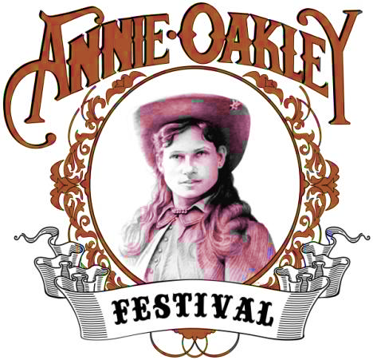
2021 Annie Oakley Festival
Vendor/Concession Application
Annie Oakley Committee, P.O. Box 129, Greenville, OH 45331
Where: Darke County Fairgrounds, Greenville Ohio 45331
Located at 800 Sweitzer St (St Rt 49), Greenville Ohio
Show Hours: Friday - Saturday, July 23rd & 24th, 2021 9:00am until 9:00pm
Sunday, July 25, 2021 - 9:00am until 5:00pm
Set Up: Tuesday, July 20 , 2021 – 2:00 pm- 7:00pm,
Wednesday & Thursday, July 21 & 22 11:00am until 5:00pm
Take Down: Sunday, July 25, 2021 - 5:00pm (No tear down prior to this time)
**please complete and return form (with fee and proof of insurance) after reading our Vendor/Concession Policy.

Name of Vendor/Concession: _______________________________________________________________
Contact Person: ____________________________________________________________________________
Address: _________________________________________________________________________________
City: _________________________________ State: _______________________ Zip: __________________
Phone No.: _______________________________ Email: ___________________________________________
Name of Owner: _________________________________________________________________
A Vendor is considered a nonfood item that can’t be consumed.
A Concession is considered food items that can be consumed and include beverages.
ONE (1) SPOT IS 14’x 14’ and includes water and electric
Vendor |  | Number of spots needed | Price $75.00 per spot
Concessioner |  | Number of spots needed | Price $200.00 per spot

For information and/or questions call Richard Robinson, 937-489-0750 (leave message) or email rickrobinson725@gmail.com

PLEASE COMPLETE THE FOLLOWING INFORMATION
items for sale (brief description): _________________________________________________________________________
_________________________________________________________________________________________

Equipment Voltage Wattage Use
___________________________ __________ __________ ________________________________
___________________________ __________ __________ ________________________________

I agree to the Vendor Policy:
Signature: _______________________________________________ Date: ___________________________

**Camping is available off Festival grounds, please call the
Darke County Fair Board (937-548-5044) for details.

Annie Oakley Festival Vendor/Concession Policy
**All exhibitor’s tent, tables, displays, cars, vans, etc. must be completely off the grounds at festival end. Absolutely NO vehicles are to be operated on show premises that are open to the public, during the established show times unless given permission from the Grounds Supervisor.
**Once you send in your application and payment, you will receive confirmation from us either through mail or email**

1. All checks Payable to: Annie Oakley Committee, PO Box 129, Greenville, OH 45331
2. Food vendors will be allowed if not in conflict with other food vendors, as approved by the Annie Oakley Committee.
3. A fee of $75.00 is due at the time of application for vendors. A fee of $200.00 is due at the time of application for concession.
3a. use of a generator is permitted during festival hours
3b. a $50 fee will be included if a 50-watt hookup is required
4. Vendors/Concession must comply with all fire and health regulations.
5. Vendors/Concessions will always keep the area of operations free from trash and debris.
6. Vendors/Concessions will always have the appropriate amount of supplies during the festival.
6a. vendors/concessions will only be allowed to be shut down for 15 min. IF a supply run is needed during festival hours.
7. Political and/or objectionable material may not be evident or on display at any time during the festival.
7a. what is considered acceptable is based on the judgement of the Annie Oakley Committee.
8. Vendors/Concessions may sell only items listed on their application or approved by the Annie Oakley Committee.
9. All wastewater, grease, and trash must be disposed of in a proper manner and in proper containers. Grease barrels are available.
10. Road, pathways, and common shared areas shall be clear and unobstructed.
11. Workers will be properly dressed, will not use objectionable language, and will maintain their area in a proper manner.
12. License and permits will be displayed as required by regulations.
13. ANY animals will always need to be restricted by a 6-foot leash during the festival.
13a. Vendor is 100% responsible for their animal. (see no. 5)
14. Vendors will abide by all rules and regulations as required by the Annie Oakley Committee. Any violation will result in cancellation of this agreement and vendor will close or vacate the festival area immediately.
15. Proof of insurance will be submitted with this application.
16. Cooperation by the vendors and festival committee will make this festival GREAT.
17. If you leave your unit at the Darke County Fair beyond Sunday, you MUST make prior arrangements with the
Darke County Fair Board, or you will be charged a $25.00 a day penalty.

