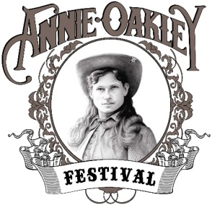
Annie Oakley Committee, Inc.
PO Box 129 Greenville, OH 45331
http://www.annieoakleyfestival.org
2021 Annie Oakley Festival
July 23, 24, & 25, 2021

The Annie Oakley Festival Committee members are very proud and excited about the upcoming 2021 Annie Oakley Festival. We were obviously very disappointed that we had to cancel the 2020 Annie Oakley Festival, which would have been our 57th year of being a festival that honors Darke County’s most famous daughter, Annie Oakley. We have already started making plans for the 2021 Annie Oakley Festival, and we are hoping are praying that this year, our festival will be bigger and better than past years. We are looking at what we, as a committee, need to do to make this year’s festival as safe as possible for all those who attend. We are looking at spacing, sanitizing, and planning events so that everyone can enjoy. Each year, our goal is to make our festival FREE to all who attend. Every activity that takes place at the Annie Oakley Festival is only made possible through the sponsorships, grants, and donations that we receive from organizations, businesses, and individuals. We are asking you to consider partnering with us for this wonderful, family oriented, time honored festival. We know that our expenses are going to be higher this year, due to all of the changes we will have to make to keep everyone safe. That is why we would greatly appreciate your sponsorship.
Listed below are the events that we are planning for the 2021 festival, and we are so grateful to all of those involved in each of these events, and the excitement that they will be bringing to our festival.

Miss Annie Oakley Shooting Contest (ages 12 - 19) & pilgrimage to Annie Oakley’s gravesite
Little Miss Annie Oakley and Miss Buffalo Bill Competition (ages 3-5)
Annie Oakley Parade
Free Historical Bus Tours
Live entertainment including many singers
Melodrama
The Whip Artistry Studio & GLD Enterprises Communication Ltd
Cowboy Mounted Shooting Association
National Fast Draw Competition
Richard Best – Buffalo Bill impersonator and story teller
Annie Oakley Car Show
Weiner Dog Races and Costume Contest
Kiddie Tractor Pulls
Souvenirs, Vendors, Concessioners, and exhibits throughout the weekend

Another way that you can help us, is by becoming a member of the Annie Oakley Festival Committee. We meet monthly (January-November, weather permitting), and we appreciate new ideas and input from our members. Having more members would help us to create an even bigger and better festival. Membership fees are only $5.00 per person, per year.
If you have any questions about our festival, and what we are planning, and how you can be a major part of the success of the 2021 Annie Oakley Festival, please feel free to contact me at
937-623-9235 or by email at: jmmelling86@gmail.com.

Sincerely,
JoEllen M Melling - President – Annie Oakley Festival Committee

